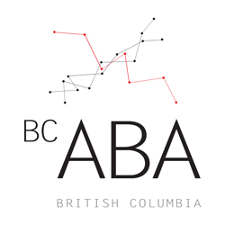 BC-ABA CONFERENCE BURSARY
2019 Application and Instructions

Description: The British Columbia Association for Behaviour Analysis will be offering up to five bursaries to assist conference attendees with the costs of traveling to the conference from other areas of the province. The bursary amount for 2019 is $150 cash plus free conference/workshop registration.

Eligibility: Applicants must meet the following requirements to be considered for this bursary:
- Be a current member of BC-ABA
- Reside in one of the following regions of British Columbia:
  - Coastal Region (e.g., Sunshine Coast, Vancouver Island, Gulf Islands)
  - Interior Region (e.g., Thompson, Okanagan, Cariboo, Kootenays)
  - Northern Region (e.g., Terrace, Prince George, Haida Gwaii, Peace region)
- Residents of Greater Vancouver, the Fraser Valley, Squamish, Whistler, and Pemberton will not be considered for this bursary

Selection Criteria: Bursary applications will be considered on a first-come, first-served basis.

To Apply: Fill out the bursary application form and submit the completed form as well as proof of address electronically to treasurer@bc-aba.org

The deadline for bursary applications is midnight on January 31, 2019. Hard copies and late applications will not be accepted.

BC-ABA

Conference Bursary Application

Personal Information
Last Name: First Name:
Address:
Email: Phone:
Address:

- Proof of address. Bursary applicants must include a scanned copy or photograph of one of the following documents:
  - Driver’s license or BC ID with address
  - Bill with your name and address (e.g., hydro, telephone, cable, etc.)

